MODULE 4 – INTRODUCTION TO DBMS

LAB EXERCISES

18. SQL Trigger
Lab 1.
Create a trigger to automatically update the last_modified timestamp of the books table whenever a record is updated.
Ans.
Add last_modified column:
1. ALTER TABLE books ADD last_modified TIMESTAMP;
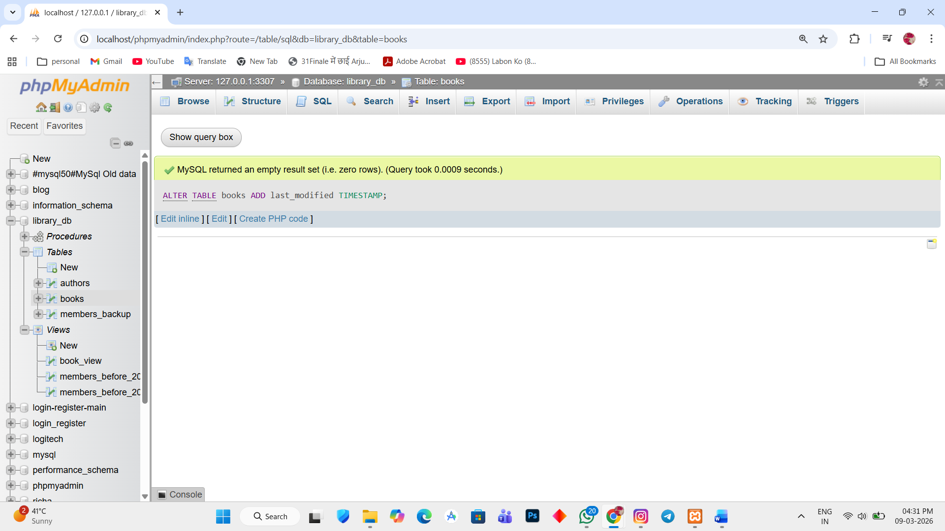

Create Trigger:
2. DELIMITER //

CREATE TRIGGER update_last_modified BEFORE UPDATE ON books FOR EACH ROW

BEGIN

SET new.last_modified = CURRENT_TIMESTAMP;

END //

DELIMITER ;
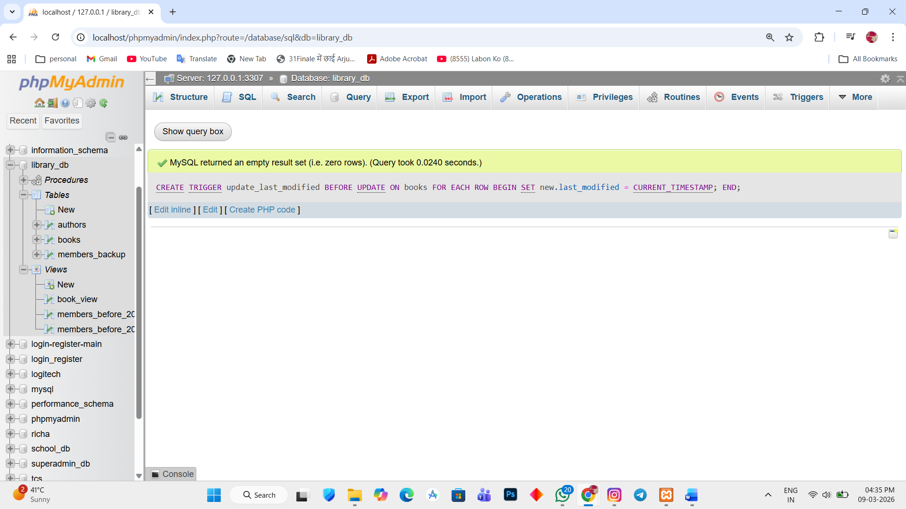

Test the trigger:
3. UPDATE books SET price = 600 WHERE book_id = 1;
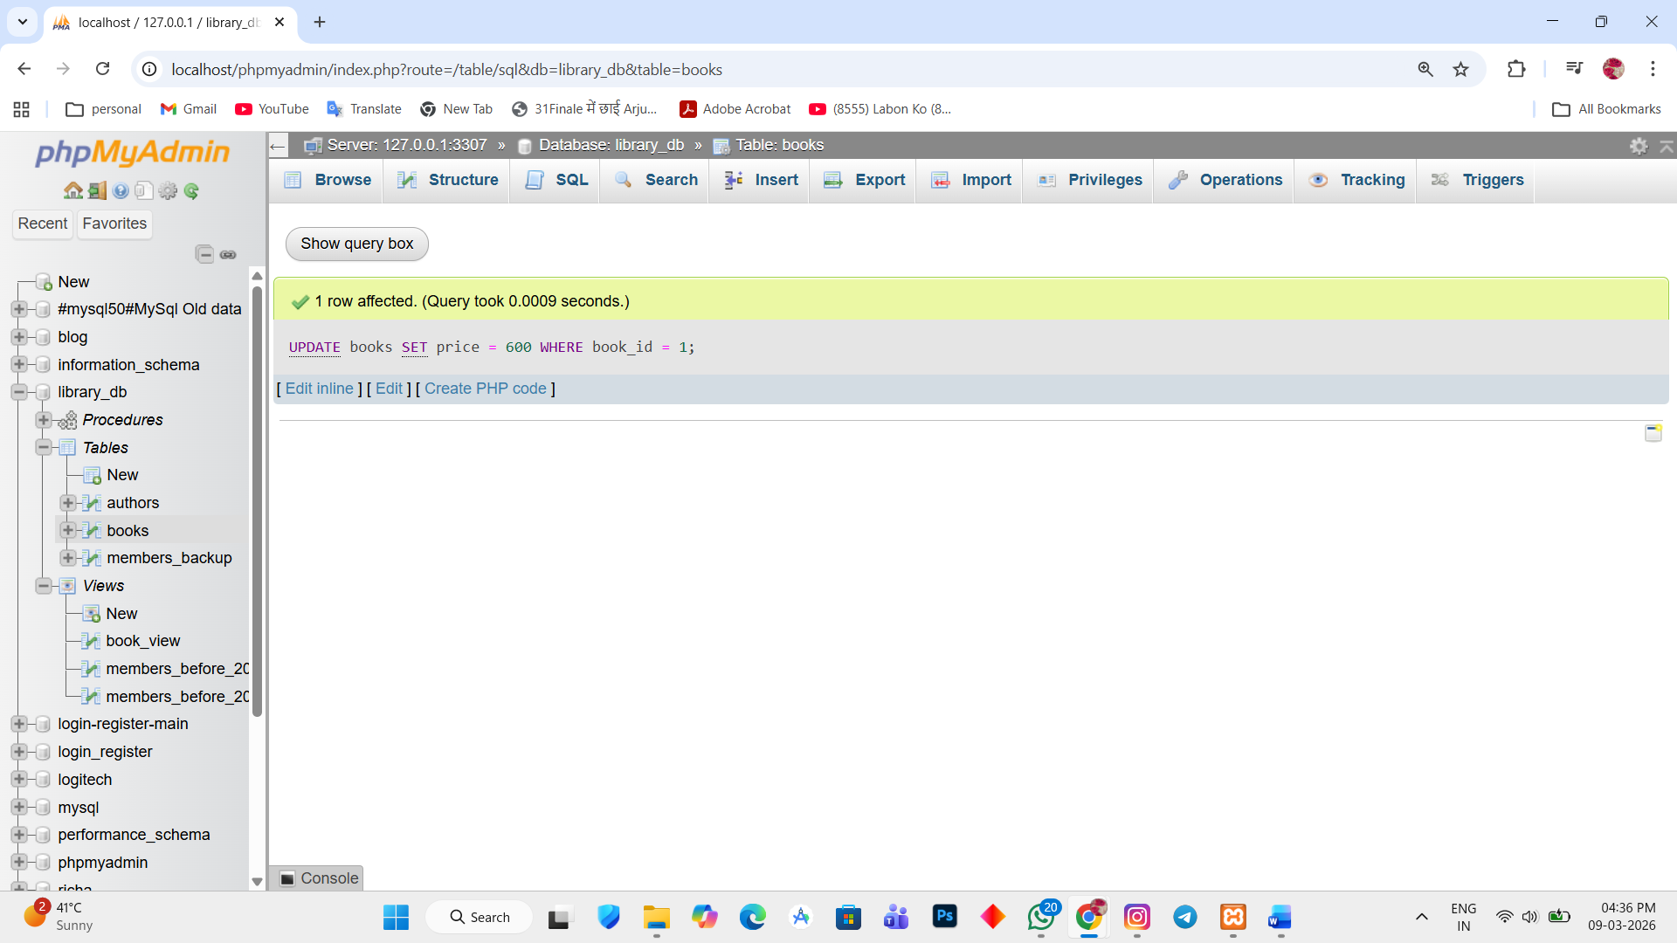

Final result:
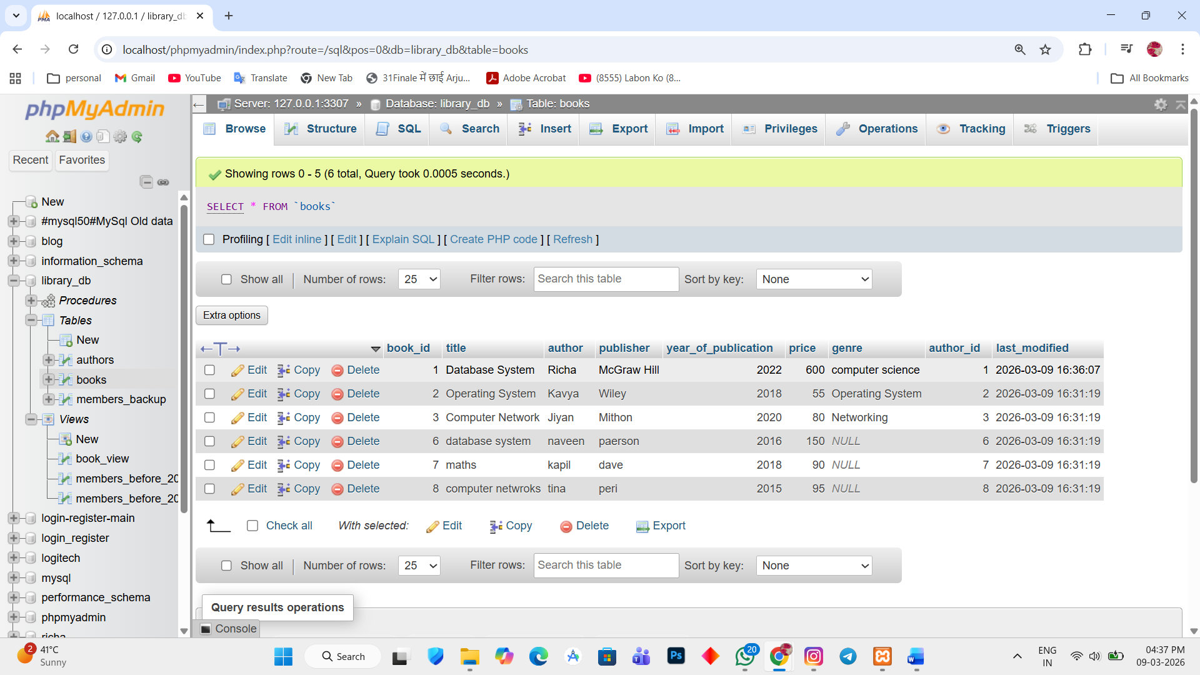

Lab 2.
Create a trigger that inserts a log entry into a log_changes table whenever a DELETE operation is performed on the books table.
Ans.
Create the log_table
1. CREATE TABLE log_changes (log_id int AUTO_INCREMENT PRIMARY KEY, book_id int, action_type varchar(255), change_time TIMESTAMP DEFAULT CURRENT_TIMESTAMP);
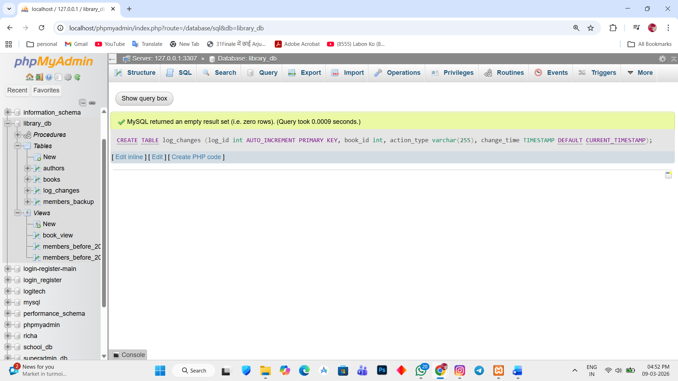

CREATE TRIGGER
2. DELIMITER //

CREATE TRIGGER log_book_delete
AFTER DELETE ON books
FOR EACH ROW
BEGIN
INSERT INTO log_changes (book_id, action_type)
VALUES (OLD.book_id, 'DELETE');
END//

DELIMITER ;

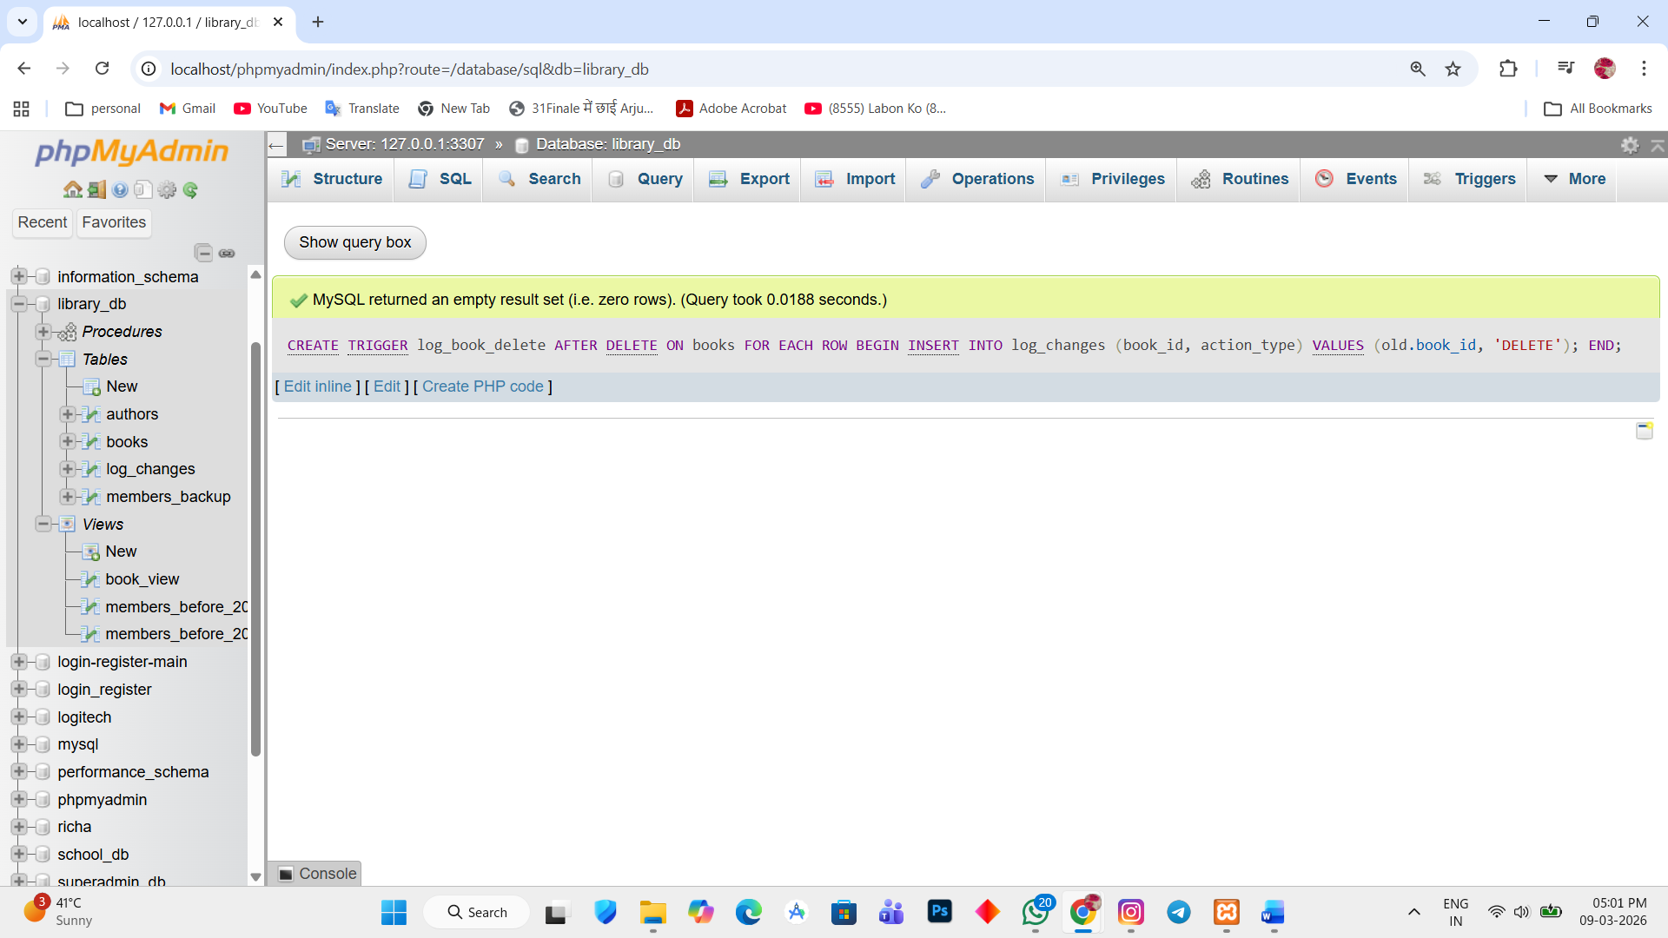

Test the trigger
3. DELETE FROM books WHERE book_id = 1;
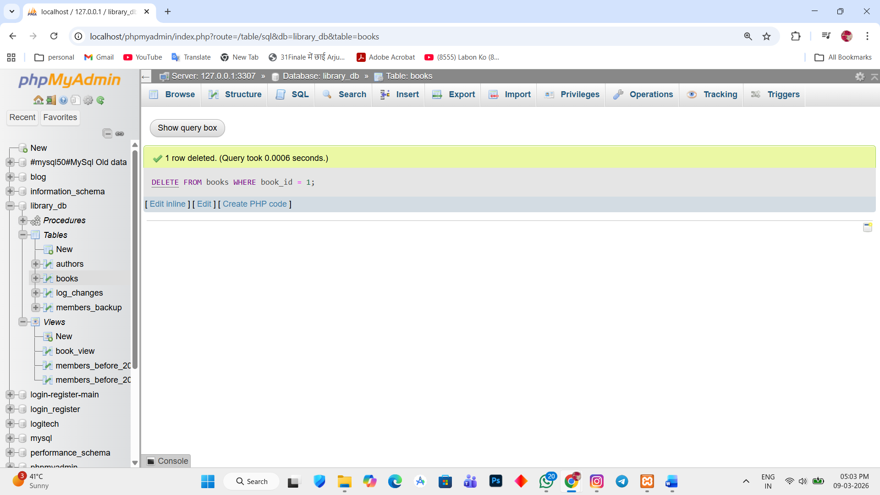

4. 